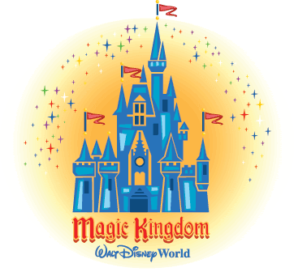
Today our trip takes us to Walt Disney World in Orlando Florida and the Magic Kingdom. Here is a list of some rides for us to ride. Go to www.youtube.com and search for each of these rides under Walt Disney World rides and the ride’s name. Example: Walt Disney World Splash Mountain. When you are finished watching, write down which ride you like the best and why.

- Pirates of the Caribbean 6. Splash Mountain
- Big Thunder Mountain 7. Haunted Mansion
- Mickey’s PhilharMagic 8. It’s a Small World
- Seven Dwarf’s Mine Train 9. Monsters Inc. Laugh Floor
- Walt Disney’s Carousel of Progress 10. Buzz Lightyear’s Space Ranger Spin

